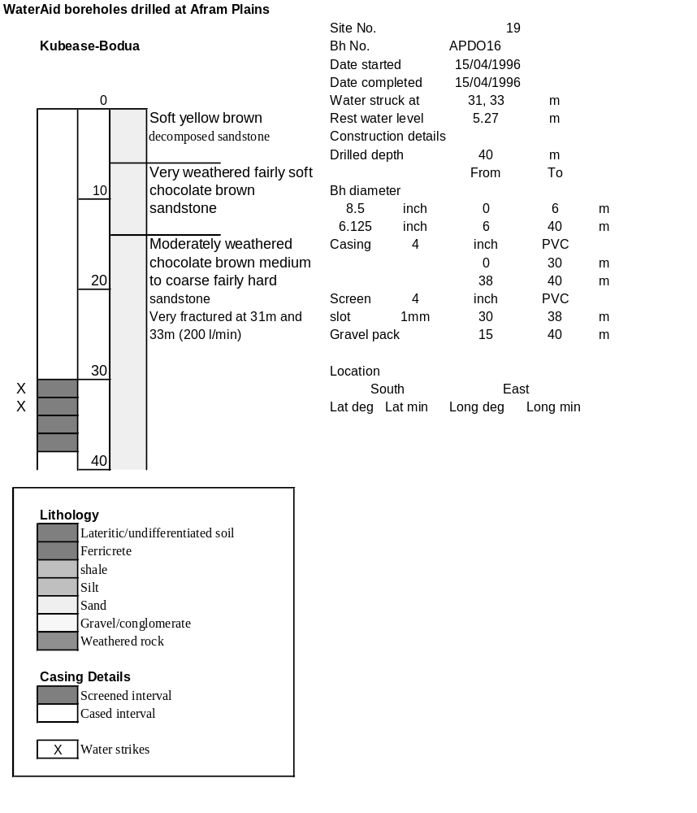

Ghana | Test pumping
Borehole No. |  | APDO16
Hole No |  | 19
Village |  | Kubease-Bodua
Date |  | 19/04/1996
Point above GL |  | 0.5 | m
Pump depth |  | 29 | m
SWL |  | 5.77 | m
Start Time |  | 08:00
Drawdown test |  |  |  |  | Recovery test
time | pwl (m) | Q l/min | dd | sc | Time | wl (m) | s' | t/t'
0.00 | 5.77 | 150.00 | 0.00 |  | 0.00 | 22.66 | 16.89
1.00 | 7.85 | 150.00 | 2.08 | 72.12 | 1.00 | 20.62 | 14.85 | 181.00
2.00 | 8.28 | 150.00 | 2.51 | 59.76 | 2.00 | 20.20 | 14.43 | 91.00
3.00 | 8.65 | 150.00 | 2.88 | 52.08 | 3.00 | 19.85 | 14.08 | 61.00
4.00 | 8.97 | 150.00 | 3.20 | 46.88 | 4.00 | 19.57 | 13.80 | 46.00
5.00 | 9.15 | 150.00 | 3.38 | 44.38 | 5.00 | 19.32 | 13.55 | 37.00
6.00 | 9.50 | 150.00 | 3.73 | 40.21 | 6.00 | 19.09 | 13.32 | 31.00
7.00 | 9.75 | 150.00 | 3.98 | 37.69 | 7.00 | 18.89 | 13.12 | 26.71
8.00 | 9.95 | 150.00 | 4.18 | 35.89 | 8.00 | 18.70 | 12.93 | 23.50
9.00 | 10.16 | 150.00 | 4.39 | 34.17 | 9.00 | 18.52 | 12.75 | 21.00
10.00 | 10.39 | 150.00 | 4.62 | 32.47 | 10.00 | 18.35 | 12.58 | 19.00
11.00 | 10.58 | 150.00 | 4.81 | 31.19 | 12.00 | 18.05 | 12.28 | 16.00
12.00 | 10.74 | 150.00 | 4.97 | 30.18 | 14.00 | 17.78 | 12.01 | 13.86
13.00 | 10.91 | 150.00 | 5.14 | 29.18 | 16.00 | 17.54 | 11.77 | 12.25
14.00 | 11.08 | 150.00 | 5.31 | 28.25 | 18.00 | 17.30 | 11.53 | 11.00
15.00 | 11.23 | 150.00 | 5.46 | 27.47 | 20.00 | 17.10 | 11.33 | 10.00
16.00 | 11.38 | 150.00 | 5.61 | 26.74 | 22.00 | 16.90 | 11.13 | 9.18
17.00 | 11.55 | 150.00 | 5.78 | 25.95 | 24.00 | 16.70 | 10.93 | 8.50
18.00 | 11.72 | 150.00 | 5.95 | 25.21 | 26.00 | 16.52 | 10.75 | 7.92
19.00 | 11.86 | 150.00 | 6.09 | 24.63 | 28.00 | 16.32 | 10.55 | 7.43
20.00 | 12.03 | 150.00 | 6.26 | 23.96 | 30.00 | 16.20 | 10.43 | 7.00
22.00 | 12.27 | 150.00 | 6.50 | 23.08 | 35.00 | 15.82 | 10.05 | 6.14
24.00 | 12.52 | 150.00 | 6.75 | 22.22 | 40.00 | 15.50 | 9.73 | 5.50
26.00 | 12.76 | 150.00 | 6.99 | 21.46 | 45.00 | 15.17 | 9.40 | 5.00
28.00 | 12.99 | 150.00 | 7.22 | 20.78 | 50.00 | 14.90 | 9.13 | 4.60
30.00 | 13.21 | 150.00 | 7.44 | 20.16 | 60.00 | 14.45 | 8.68 | 4.00
35.00 | 13.75 | 150.00 | 7.98 | 18.80 | 70.00 | 14.04 | 8.27 | 3.57
40.00 | 14.27 | 150.00 | 8.50 | 17.65 | 80.00 | 13.67 | 7.90 | 3.25
45.00 | 14.80 | 150.00 | 9.03 | 16.61 | 90.00 | 13.33 | 7.56 | 3.00
50.00 | 15.22 | 150.00 | 9.45 | 15.87 | 100.00 | 13.01 | 7.24 | 2.80
55.00 | 15.62 | 150.00 | 9.85 | 15.23 | 110.00 | 12.78 | 7.01 | 2.64
60.00 | 16.03 | 150.00 | 10.26 | 14.62 | 120.00 | 12.57 | 6.80 | 2.50
70.00 | 16.80 | 150.00 | 11.03 | 13.60
80.00 | 17.53 | 150.00 | 11.76 | 12.76
90.00 | 18.19 | 150.00 | 12.42 | 12.08
100.00 | 18.82 | 150.00 | 13.05 | 11.49
110.00 | 19.42 | 150.00 | 13.65 | 10.99
120.00 | 19.95 | 150.00 | 14.18 | 10.58
130.00 | 20.45 | 150.00 | 14.68 | 10.22
140.00 | 20.91 | 150.00 | 15.14 | 9.91
160.00 | 21.83 | 150.00 | 16.06 | 9.34
180.00 | 22.66 | 150.00 | 16.89 | 8.88
